1. Liberty University
2. CSIS 331
3. Lab 9 Instructions
4. Packet Tracer:
5. *[Adapted from Cisco Networking Academy Routing and Switching 1.1.1.9]*
6. Topology

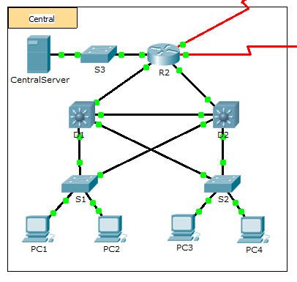

1. Background

In this activity, your job is to document the addressing scheme and connections used in the Central portion of the network. You must use a variety of commands to gather the required information.

**Note**: The user EXEC password is **cisco**. The privileged EXEC password is **class**.

1. Requirements

* Access the command line of the various devices in Central.
* Use commands to gather the information required in the **Addres Table on your Answer Sheet**.
* If you do not remember the necessary commands, you can use the IOS built-in help system.
* If you still need additional hints, refer to the **Hints** page. In Packet Tracer, click the right arrow (>) on the bottom right side of the instruction window. If you have a printed version of the instructions, the **Hints** page is the last page.

1. Hints

Use the following commands to gather the information you need to document the network:

show ip interface brief

show interfaces

show running-config

ipconfig